**Selenium Grid**

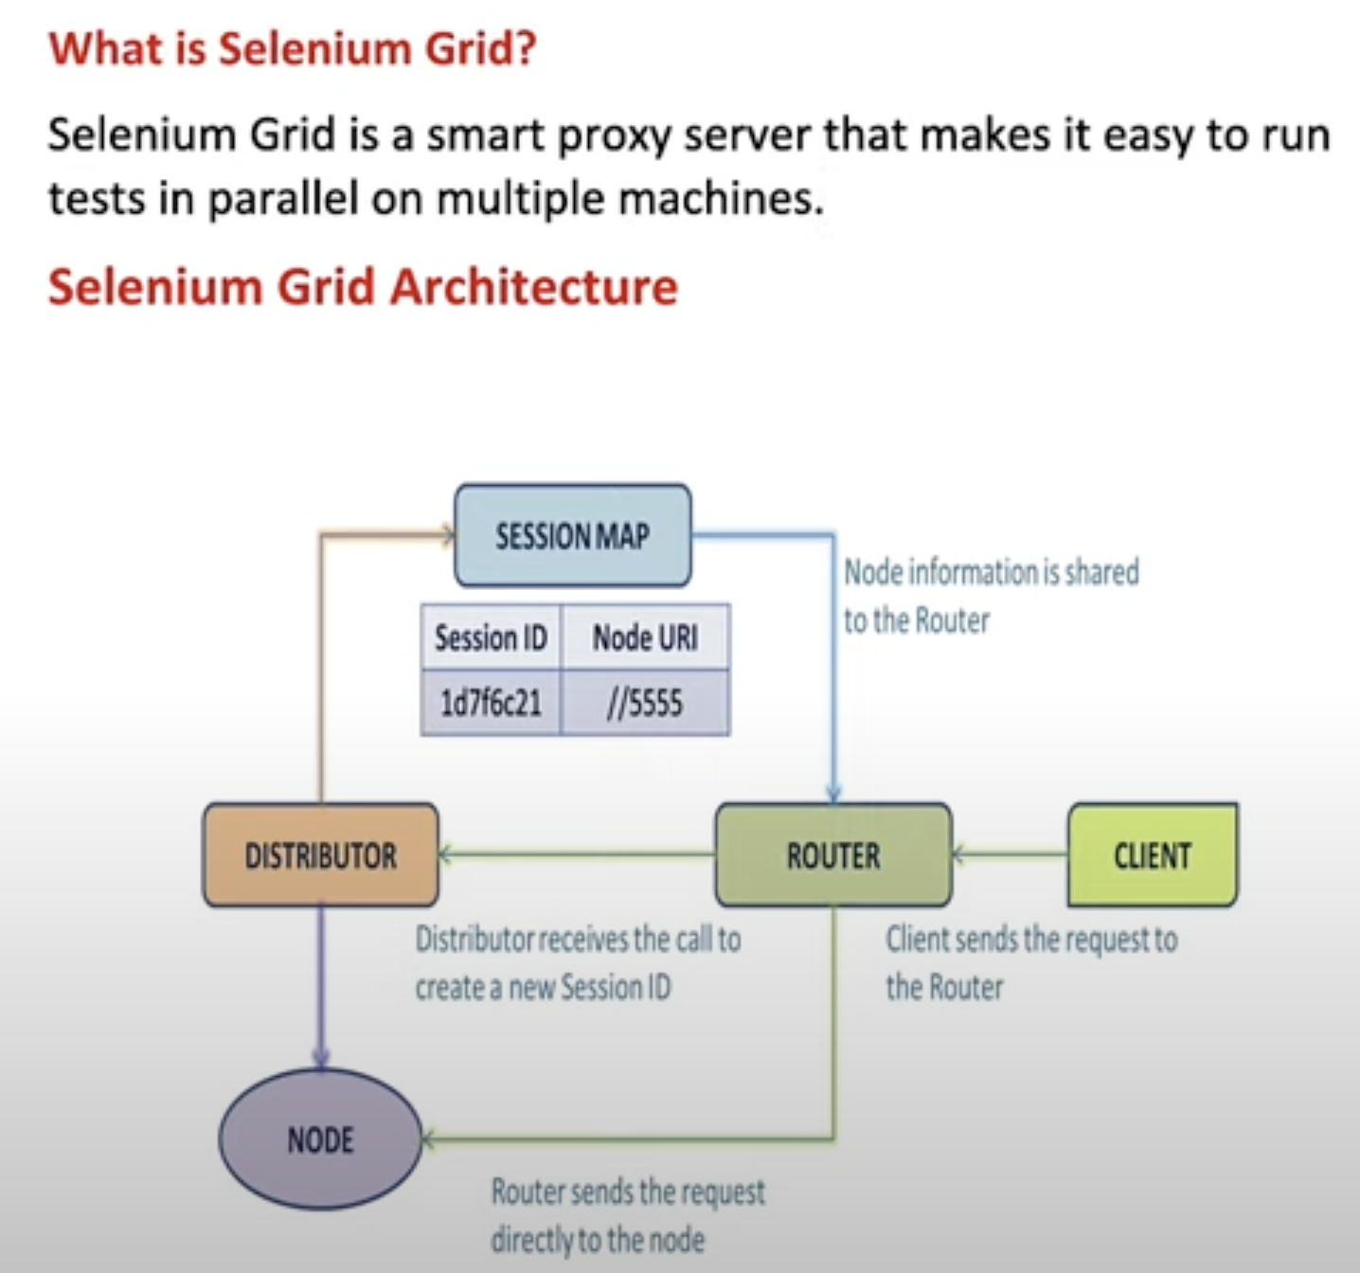

* Client send request to router, 1st time it will send to Distributor.
* Distributor will send request to Node, get the info and sent to Router using Session Map.
* Next line onward it will directly send to Node(Because we have node information now)

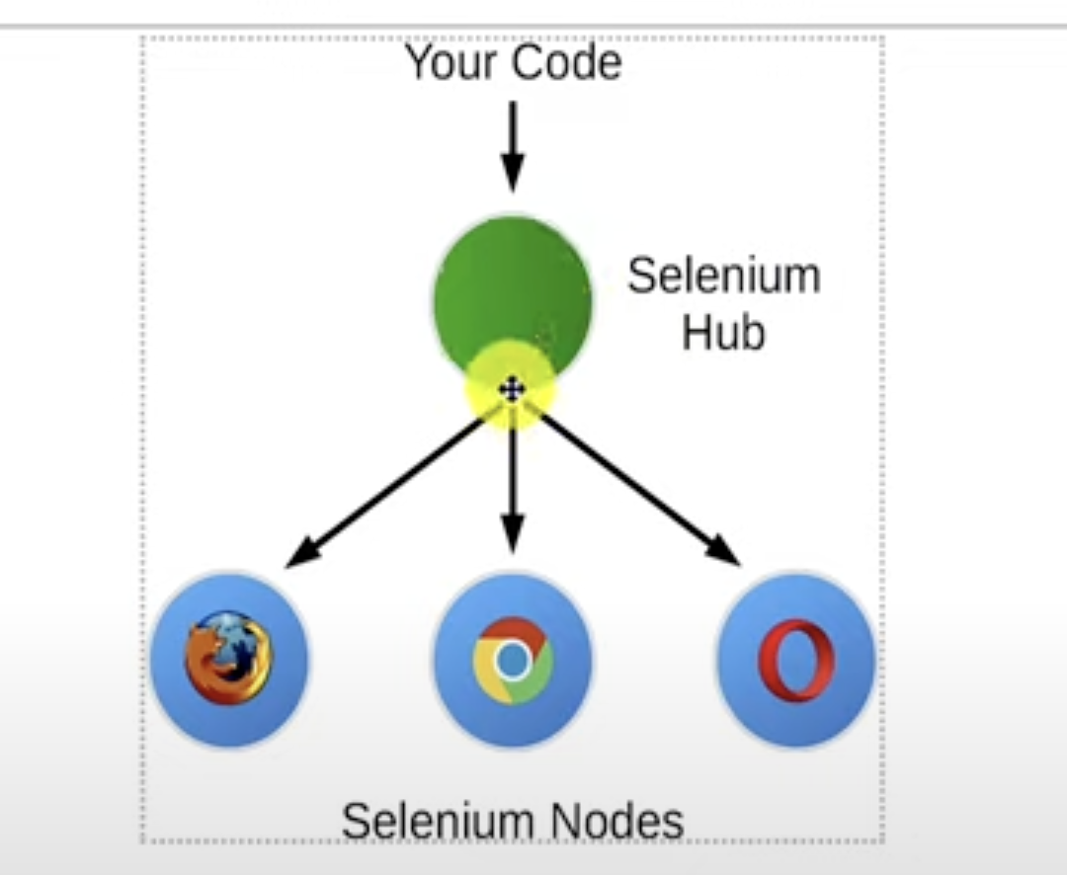

**Selenium Grid setup using Hub & Node:**

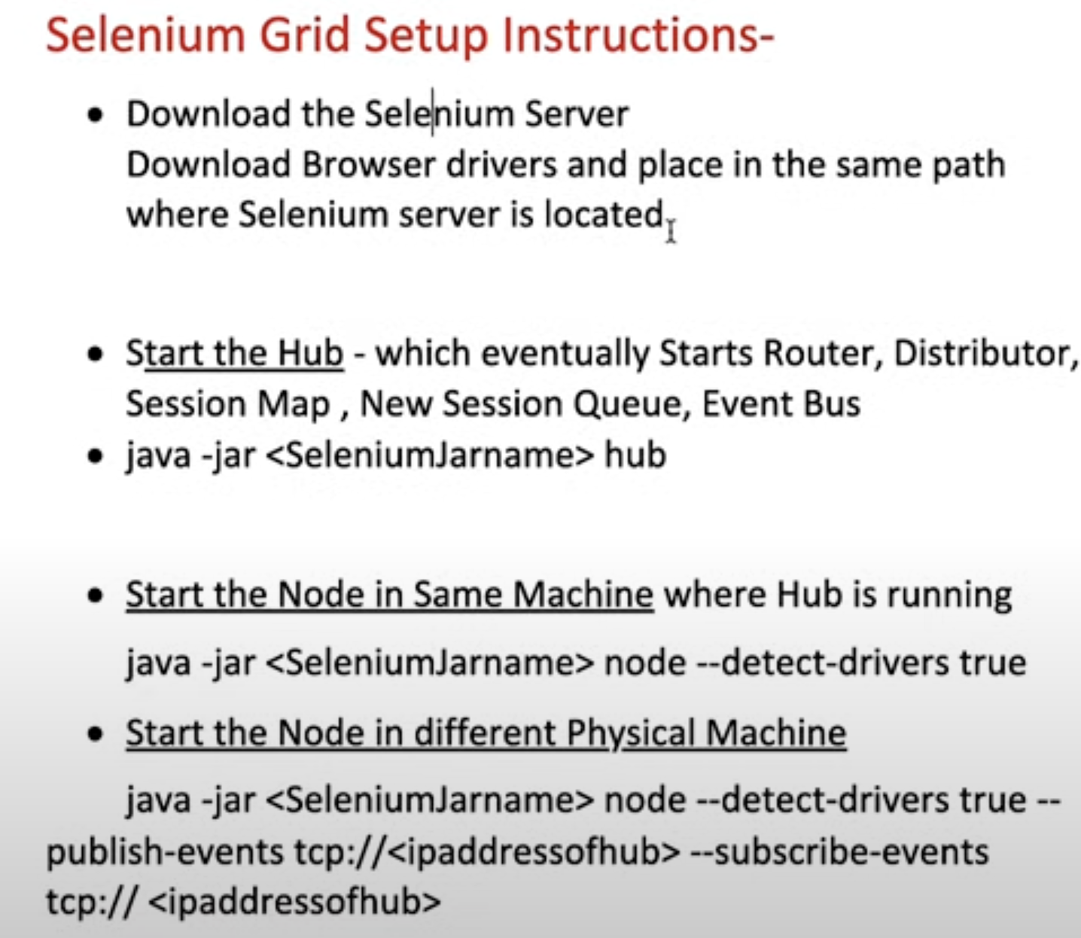

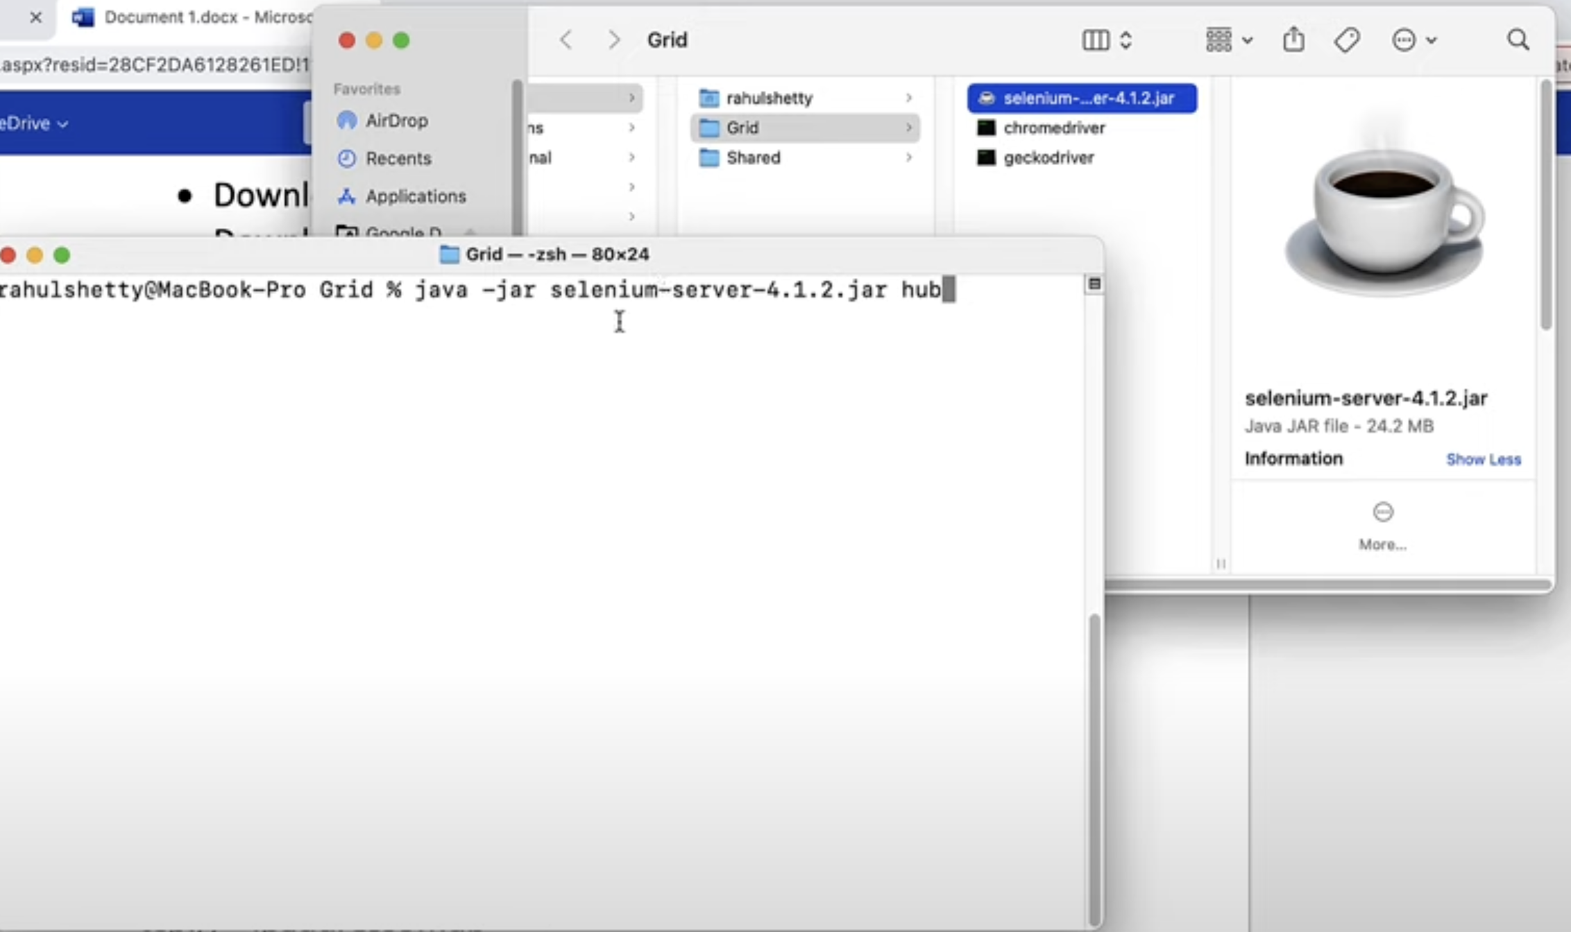

**Check the status of Hub:** Default port is 4444

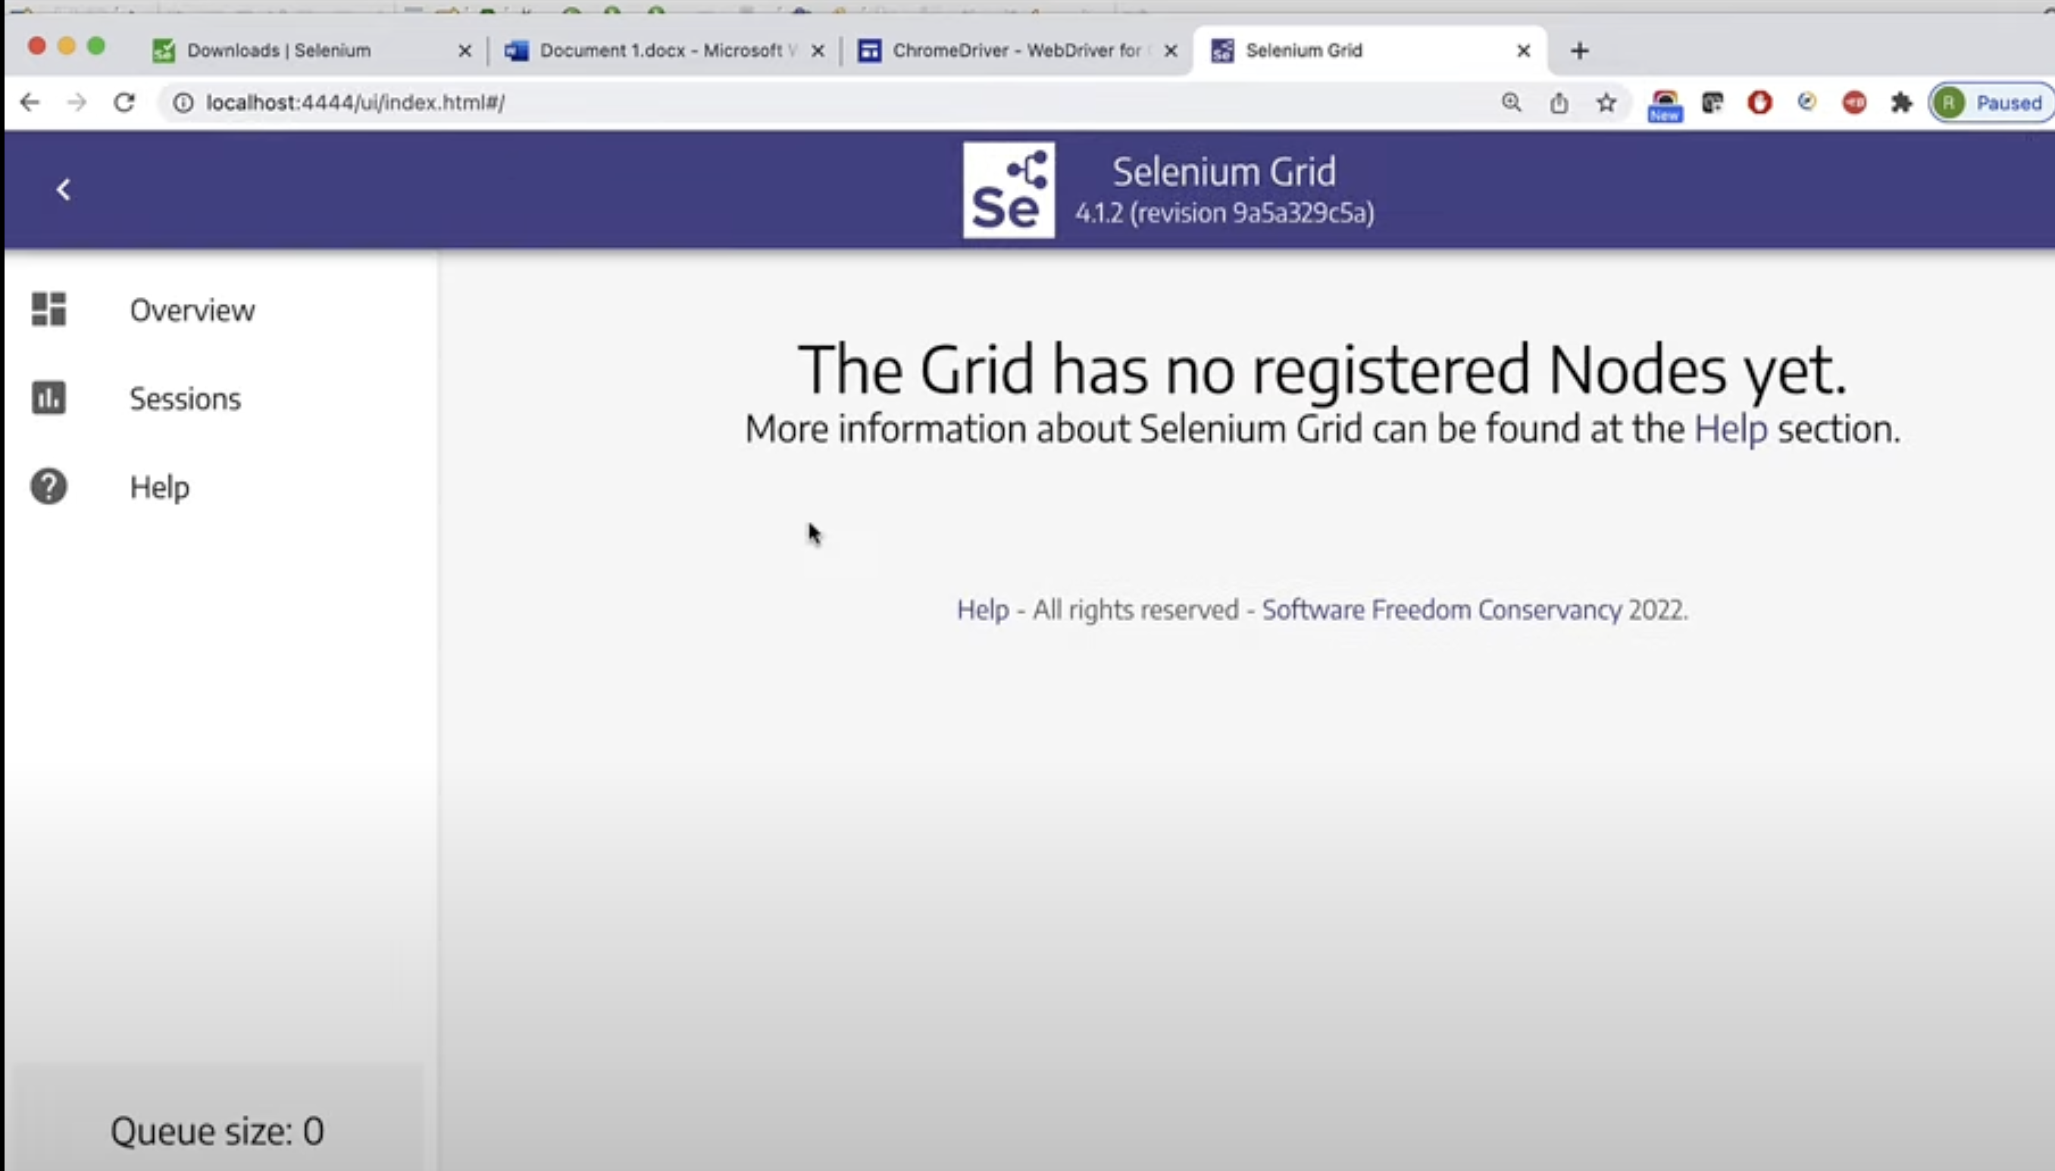

**Node in the same machine where HUB is present:**

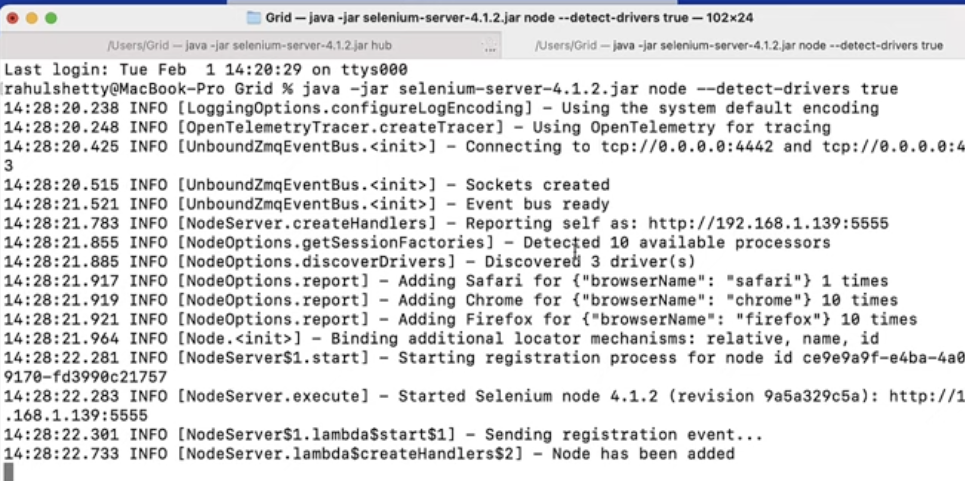

**Now we can see Nodes:**

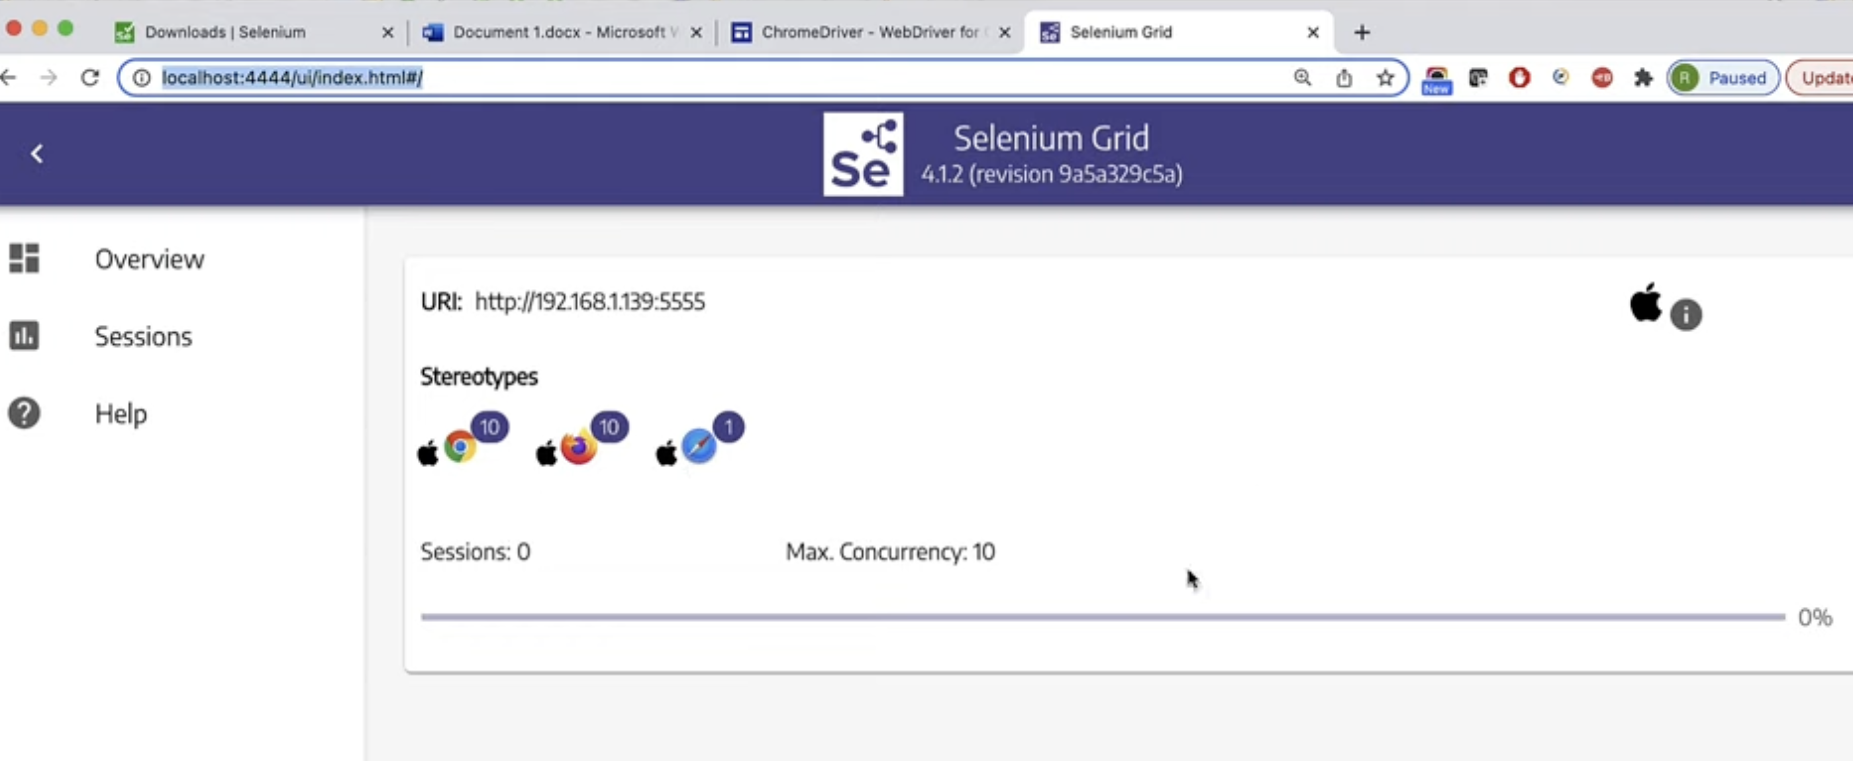

**Go to Hub : you will see Added node**

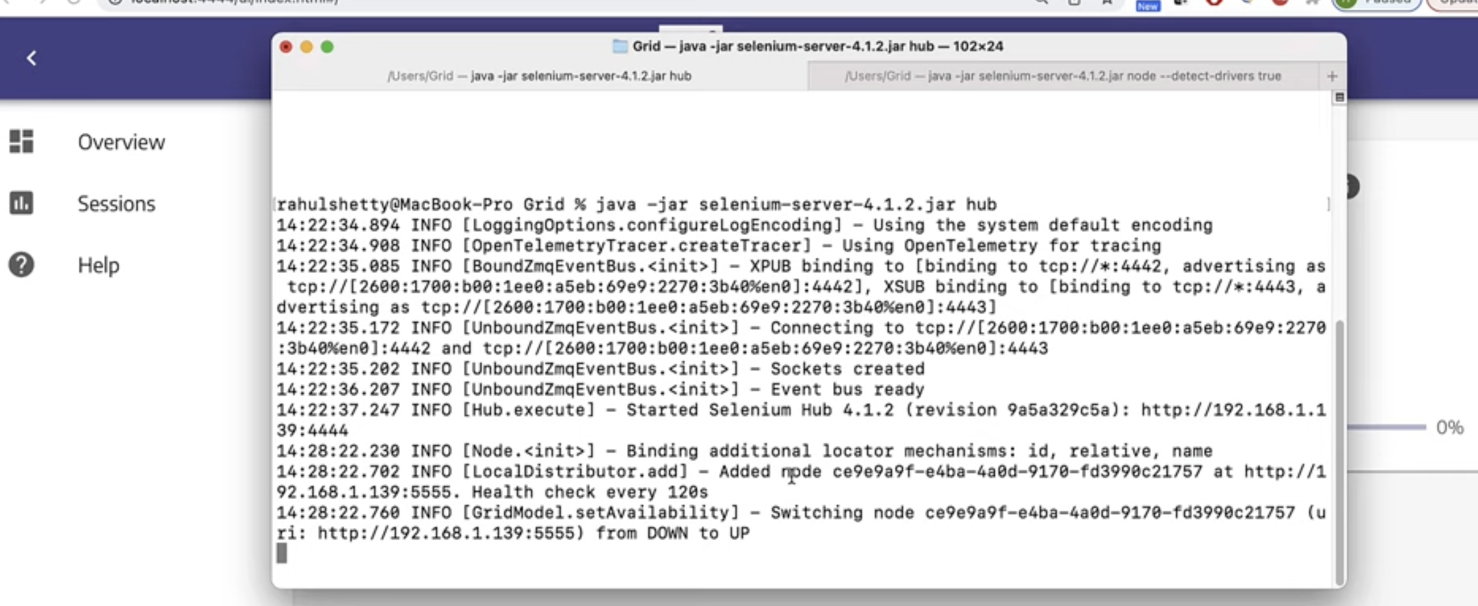

**Different machine setup(Node in the different machine): Here we have to register nodes with hub**

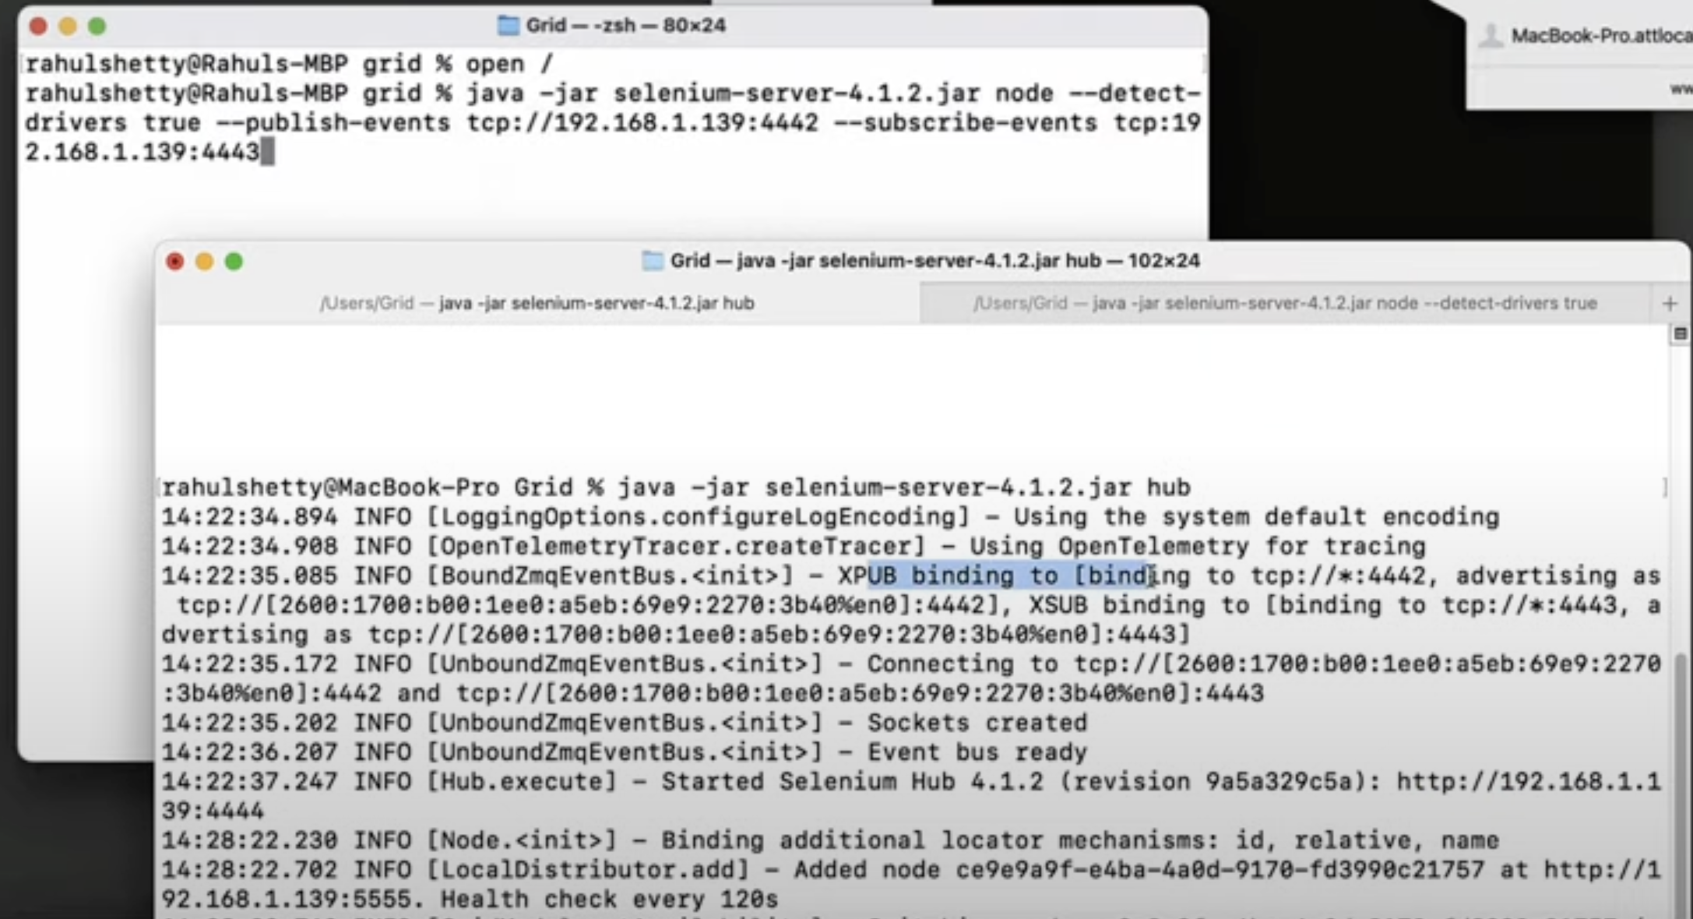

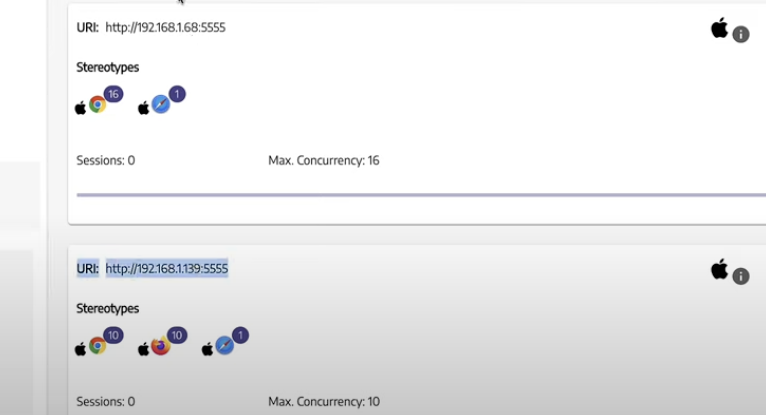

**Code:**

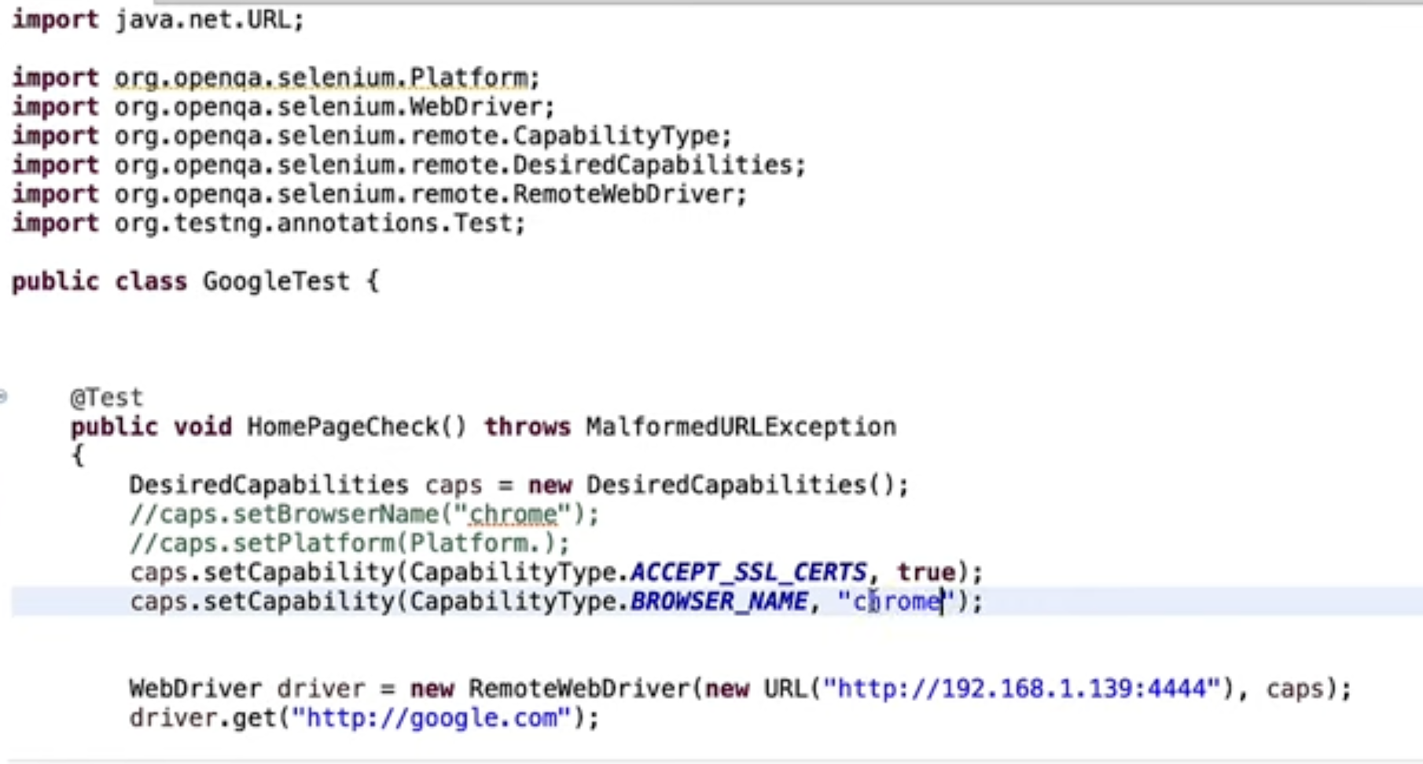

**Different Grid Infrastructure:**

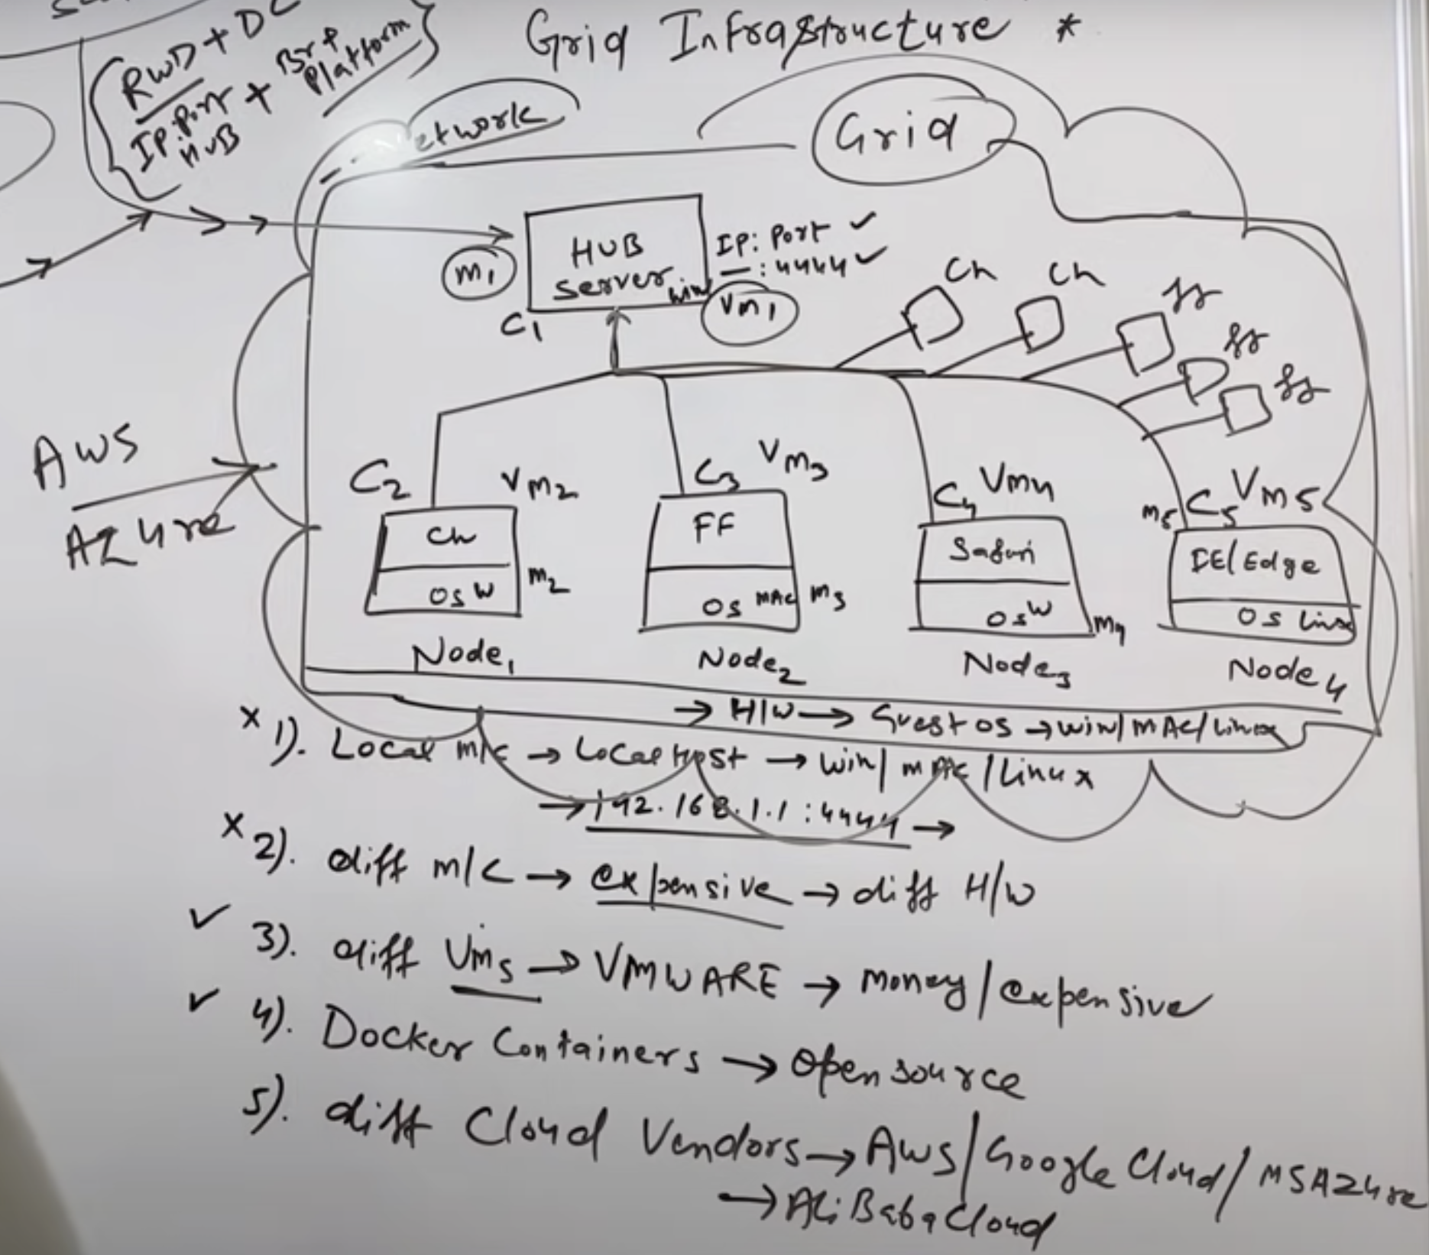

* Local Machine : Localhost
* Different Machine : will be very costly, scalability is a big issue.
* Different VM’s : will be very costly, scalability is a big issue.
* Docker container : Free, easy to scale
* Different cloud platform : Azure, AWS : simple to create multiple instance, easy to scale.
* Browerstack/Saucelabs cloud : Everything will be taken care by these platform, they will provide you Private key and some details.
* Lambdatest